My Name is
______,
[INSERT THE NAME OF THE CHILD.]
and I Am Happy!

[INSERT A PHOTO OF THE CHILD.]

Susanne M. Alexander
and [INSERT THE NAME OF THE PERSON
CUSTOMIZING THE BOOK]

Quotation for Reflection:
‘Abdu’l-Bahá began by saying, as he seated Himself: “Are you happy?” and our faces must have shown him that we were. He then said: “I love you all, you are the children of the Kingdom, and you are accepted of God.”
~ ‘Abdu’l-Bahá, ‘Abdu’l-Bahá in London, p. 85

© 2012 Marriage Transformation LLC

This book has been created and distributed by Marriage Transformation LLC as part of its effort to transform individuals, marriages, and families globally. The Marriage Transformation Social Action Project is committed to empowering people to create happy, lasting, spiritually-based marriages—the foundation of a prosperous, unified world. It creates practical resources and powerful learning opportunities focused on character to support successful marriage preparation, and to sustain and balance the spiritual, emotional, intellectual, and physical aspects of married life.

When children have well-developed characters, this will help prepare them to be happy and to establish healthy, lasting marriages later in their lives. This book is part of the project’s series of customizable character-related children’s books.

Permissions: Those who download this book from www.bahaimarriage.net have permission from Susanne M. Alexander at Marriage Transformation LLC to customize the book for a child and to print the book with their own equipment or through a commercial printer. Customization can include making the content match the child’s life and replacing some graphics with photos of the child and the child’s activities. The photos and graphics in this book provided by Marriage Transformation LLC cannot be used for any other purpose other than for the content of this book without appropriate permission.

We welcome an interactive relationship with readers and users of our books and materials. Your generous editorial suggestions are a blessing. The review/editing team for this book included: Jen Chingue, Fanya DeMaria, Krsnanandini Devi Dasi, Linda Gruenspan, Yvonne Gustafson, Jane Ives, Johanna Merritt Wu, Terri Muuss, and Reggie Newkirk.
______

Marriage Transformation Social Action Project
Email: Susanne@marriagetransformation.com
Websites: www.marriagetransformation.com; www.bahaimarriage.net
‘Abdu’l-Bahá was happy. He asked everyone, “Are you happy?”

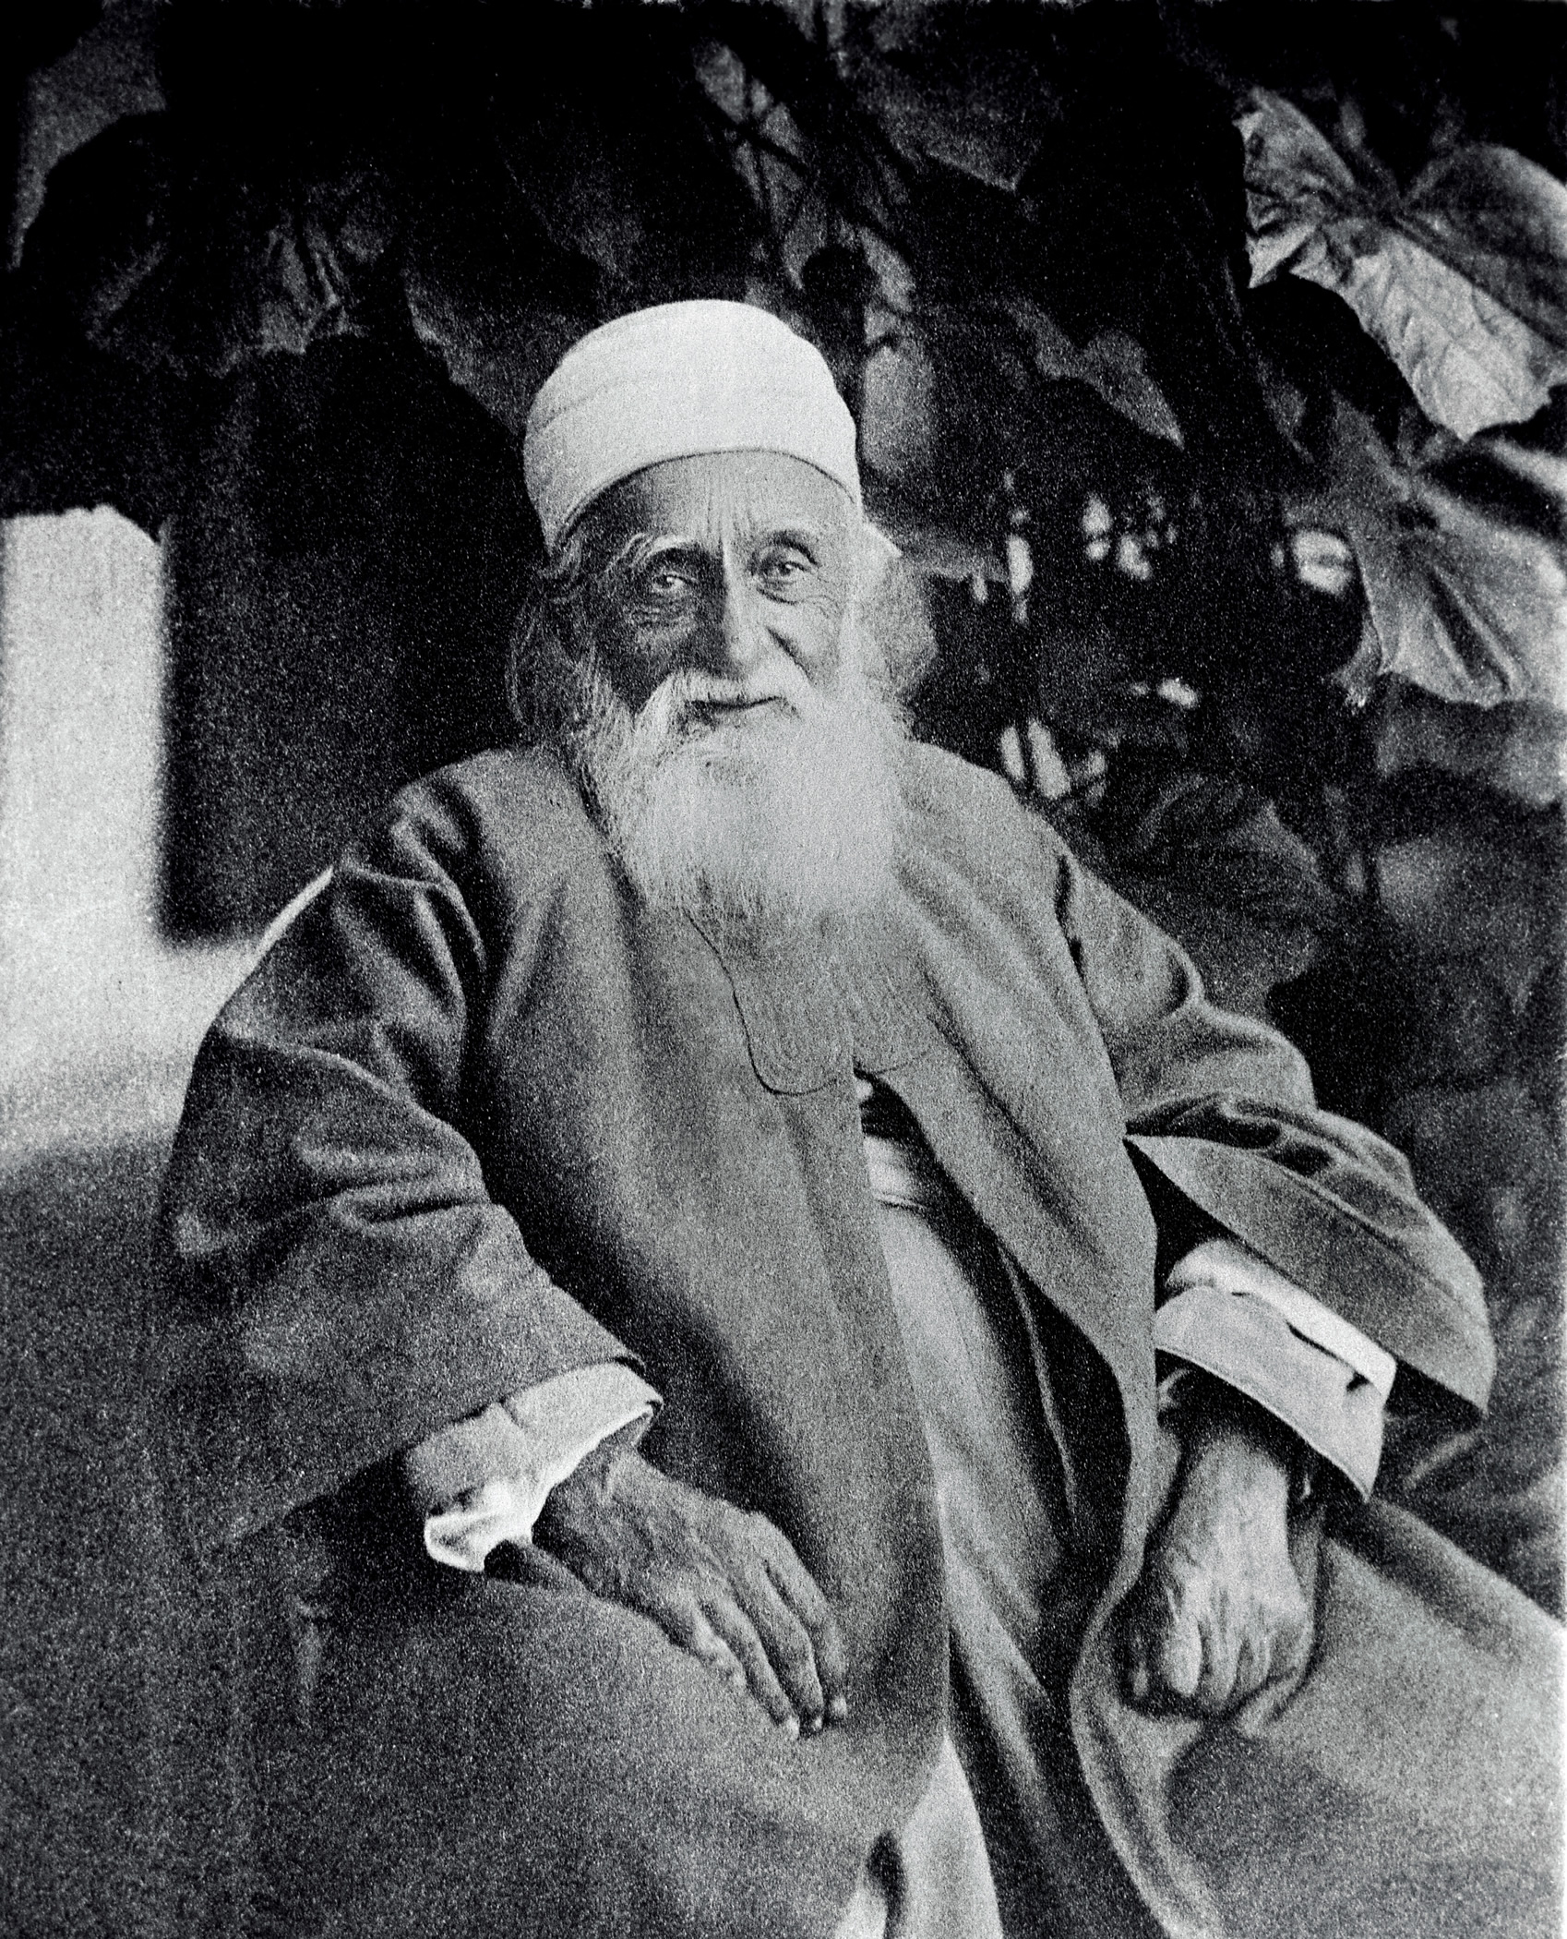

Reprinted with permission of the Bahá’í International Community (http://media.bahai.org)

He smiled. He laughed. He told funny stories.

‘Abdu’l-Bahá helped people to love God and Bahá’u’lláh.

He did many things that made people happy.
“What makes you feel happy?” asks Everyone.

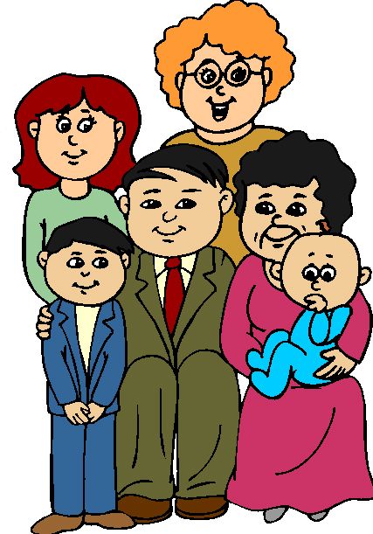
“I am happy that my mother loves me,” says Chick.

“I am happy that my father loves me,” says Rabbit.

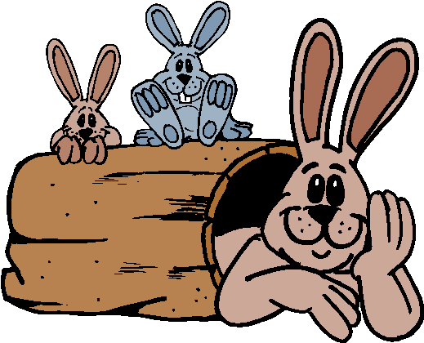
“I am happy when I pray with my family or at Bahá’í children’s classes,” says Mouse.

“I am happy when I think of God,” says Deer.

“What makes you feel happy?” laughs Dog.

“I am happy when I visit and play with my friends. They are happy, too,” says Mouse.

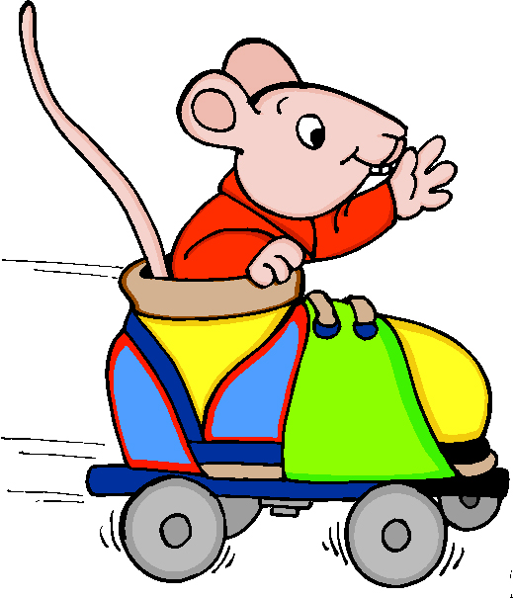
“I am happy when Worm helps me with a ride to Bahá’í children’s classes,” says Ladybug. “I’m happy to be of service to Ladybug,” says Worm.

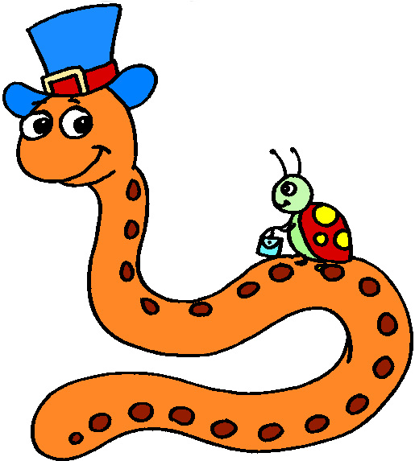

“I am happy when I can swim with my family to go to the Feast,” says Fish. “I am happy when I can give to the Bahá’í Fund at Feast.”

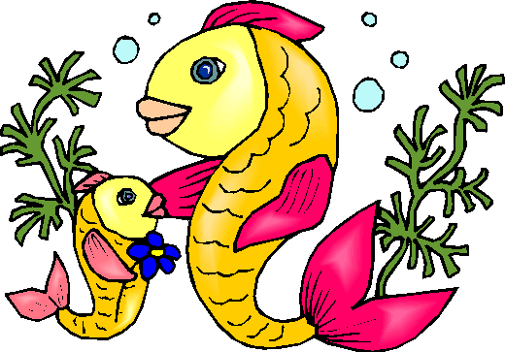
“What makes you feel happy?” jumps Bear.

“I am happy when I am clean,” says Elephant.

“I am happy when I read books or someone reads books to me,” says the Boy.

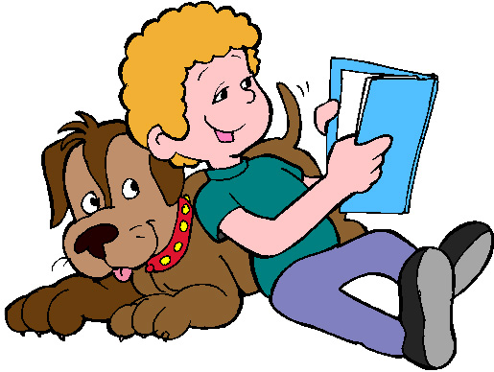

“I am happy when I am gentle with my Cat,” says the Girl. “Cat is happy when I am gentle, too!”

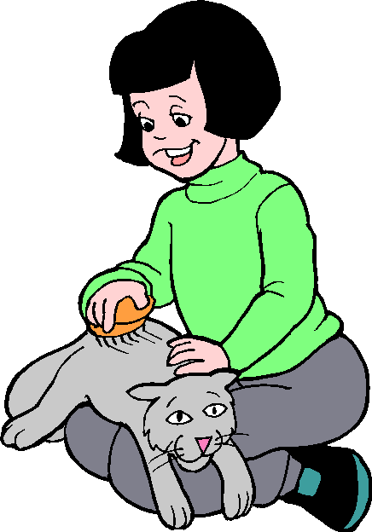
“How can I tell when you feel happy?” asks the Boy.
I smile and laugh when I feel happy,” he says.

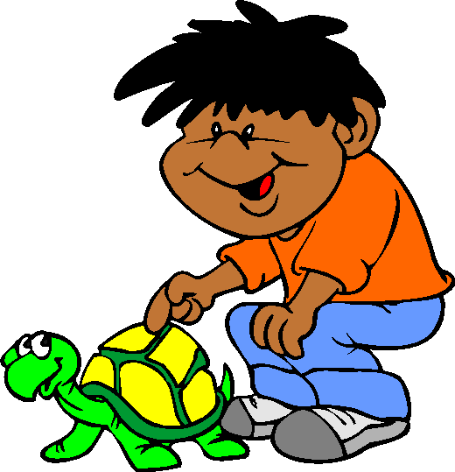

“I sing when I feel happy,” says Bird. “When I sing, it helps others to feel happy, too.”

“I feel happy when I help my parents,” says the Girl.

“I color flowers when I am happy,” says the Girl.
“I give the pictures to my family and friends. That helps them to feel happy, too!”

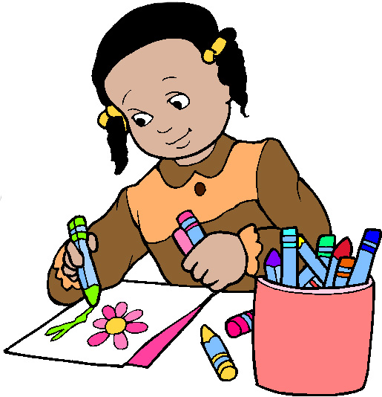
”I am happy when I think about how much
‘Abdu’l-Bahá loves me,” says [INSERT THE NAME OF THE CHILD.]

Reprinted with permission of the Bahá’í International Community (http://media.bahai.org)

‘Abdu’l-Bahá wants to know:

“Are YOU happy?”

“Yes, I am happy!”
says _________
[INSERT THE NAME OF THE CHILD.]

[INSERT A PHOTO OF THE CHILD.]

